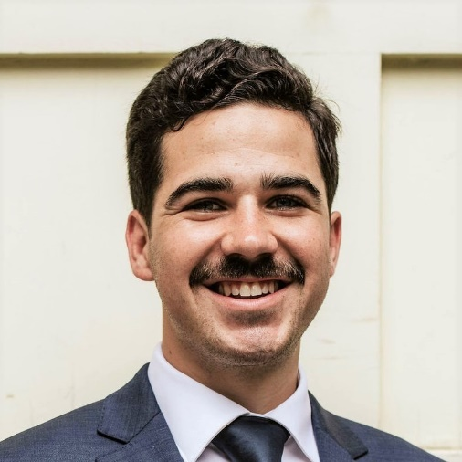

Raised on a working ranch in west Texas, Will has loved being outside and working with his hands about as long as he can remember. He loves spending time with his wife and daughter, learning new folk and traditional crafts, and daydreaming of being a master builder.

Will McCartney, E.I.T.
Will joined MMY in January 2024. During his fledgling career, he has enjoyed working on a wide variety of structures, from designing small lake cabins to adaptive reuse of downtown high rises. A bulk of Will’s experience has come from assessment, stabilization, and modifications of existing structures and his passion lies in helping bring just a little bit more beauty into the world.
Notable projects that Will has played a key role in prior to MMY:
Heritage House Stabilization and Repair – Saint Paul, MN
Stabilization and repair of a NRHP-listed late 1880s 4-story structural masonry building with front and rear walls that had buckled outwards upwards of 6 inches. Developed a steel tension rod system to restore diaphragm integrity and stitch the two facades together, while navigating historic requirements and obtaining MN State Historic Preservation Office approval.
Woodhill Country Club Expansion – Wayzata, MN
Two story modification and expansion of an early 1900s wood barn into state-of-the-art golf clubhouse, dining area, and event space. Project included integration of a steel lateral system to accommodate removal of the barn’s hayloft.
Cathedral of Saint Paul Assessment – Saint Paul, MN
Condition assessment and structural review of the NRHP-listed Cathedral of Saint Paul. Project included research of historic documents to identify the source of unexpected field conditions, as well as multi-disciplinary collaboration to provide the first comprehensive assessment of the city’s most iconic structure in over twenty years.
Education
Bachelor of Science in Civil Engineering,
Benedictine College, 2020

Post-Graduate Diploma in Architecture,
Building Beauty, 2025 (Anticipated)
Registration and Memberships
Engineer-in-Training, Minnesota

